MED D - Fulfillment Request

High Level Process
Determination Table
Medicare D Fulfillment
Fulfillment – Alternate or Accessible Formats
Fulfillment – Non-English Language
Viewing Medicare D Fulfillment
Medicare D Monthly Explanation of Benefit (EOB)
Digital Evidence of Coverage, Formulary and Pharmacy Directory
Resolution Manager Task
Fulfillment Automation
Related Documents

Description: This document will assist the CCR with accurately and efficiently fulfilling a Medicare Part D beneficiary’s literature request and help to determine if requests should be ordered through the Participant Inquiry screen, Medicare D Inquiry screen, and RM Task.

High Level Process
- Use the Determination Table to assist with how to request fulfillment items for a beneficiary.  - If SilverScript or BlueMedicare Rx (NEJE) are requesting one of the following items for current year, proceed to step two.  - Annual Notice of Change (ANOC)  - Coordination of Benefits Survey Letter  - Disenrollment Form  - LIS Rider  - IRMAA letter ID S026  - Replacement ID card (includes an ID card)  - Welcome Kit  - If SilverScript or Blue MedicareRx (NEJE) are requesting a Comprehensive Formulary, Evidence of Coverage or the Pharmacy List Directory, refer to MED D - Digital Evidence of Coverage, Formulary and Pharmacy Directory. | Reminder: Before attempting to resolve any fulfillment request, the CCR will review the CIF to determine if CVS Caremark handles the fulfillment for the client.  Notes: Beneficiaries also may request letters in a non-English language or accessible format. Refer to the Fulfillment – Alternate or Accessible Formats or Fulfillment – Non-English Language section of this document.
- Request the fulfillment item from Fulfillment Requests on the Medicare D Inquiry Tab in PeopleSafe. | Note: If the Fulfillment List is not populated, submit an RM Task.
- Verify the beneficiary’s address and update as needed.

- Explain next steps.

Top of the Document

Determination Table
The following table will guide the CCR as to which process should be used when requesting fulfillment items for a beneficiary enrolled in a SilverScript (EGWP and PDP) or Blue MedicareRx (NEJE) plan.

Note: For clients other than SilverScript or Blue MedicareRx (NEJE) the CCR will check the Fulfillment dropdown in PeopleSafe.
- If the form is listed, it can be sent to the beneficiary
- If not, refer the beneficiary back to the client.

There will be new documents designated for FUTURE YEAR beginning in October. These are abridged formulary, Welcome Kit, Annual Notice of Change and Comprehensive Formulary. These fulfillments designated as FUTURE YEAR will be available during a particular timeframe (October 1 through December 31 every year) and should be used when selecting fulfillments for the upcoming plan year. For the rest of the year, the Future Year Fulfillments will not be available for CCRs to fulfill.

Fulfillment Item | System to be used for Request | Process
Abridged Formulary  Note: If an abridged formulary is requested, the beneficiary will be sent the comprehensive formulary. | EOC, Formulary and Pharmacy Directory Request Portal | Refer to Comprehensive Formulary.
Annual Notice of Change (ANOC) | PeopleSafe: Medicare D Inquiry tab | - You can access this detail on our website at www.aetnamedicare.com or Blue MedicareRx (NEJE) website www.rxmedicareplans.com  OR  - I can request one for you.
Annual Notice of Change (ANOC) | PeopleSafe: Medicare D Inquiry tab | If the beneficiary… | Then…
Annual Notice of Change (ANOC) | PeopleSafe: Medicare D Inquiry tab | Says he/she will print the ANOC from the website | Document and close the call according to current policies and procedures.  Refer to the MED D - Call Documentation work instruction.
Annual Notice of Change (ANOC) | PeopleSafe: Medicare D Inquiry tab | Asks the CCR to request an ANOC | Only Future year ANOC’s will be available for Customer Care selection from October 1 through December 31 of each year for the upcoming plan year.  For Current year ANOC requests, (January 1 through October 14th of each year), submit the following RM Task:  Task Category: Med D Enrollment - Fulfillment  Task Type: Fulfillment Request  Queue: Med D Enrollment Task  Notes: Include detailed notes:  - Who is placing the request (i.e. beneficiary, POA, AOR or legal representative)  - Indicate if the request is for the current or future benefit year.  - Current Year requests: Only the ANOC booklet will be sent.  - All other items that are included in the ANOC packet should be ordered. Refer to the Medicare D Fulfillment section of this work instruction.  Refer to the MED D - SilverScript and Blue MedicareRx (NEJE) - Enrollment Related RM Tasks.
Appeals Letter varies by client. Validate in Plan Design. | CIF | Appeals information in CIF.  Note: If an exceptions form is required, the following notes should be included in the task:  Comments: Exception form needed (Example: DAW, Tier Exception), prescriber’s name, prescriber’s fax number, name of the medication, and any other information to assist their peers for history and tracking purposes. An exception form will be sent to the prescriber if this information is included.
Assignment of Benefits (AOB) Form | PeopleSafe: Order Fulfillment | Refer to Fulfillment Automation.
Authorization Release Form | PeopleSafe: RM Task | Extended Authorization Release Form: Resolution Manager Task  One-time Authorization Release Form: Resolution Manager Task or beneficiary can download on their Web Portal.  Refer to MED D - Appointed Representative Form (AOR) or Power of Attorney (POA).  Do NOT use fulfillment automation in PeopleSafe.
Cancel Fulfillment Order | PeopleSafe: Order Fulfillment | Refer to Fulfillment Automation.
Claim Forms | PeopleSafe: Order Fulfillment | Refer to Fulfillment Automation.
Claim Form for Compound Prescription | PeopleSafe: RM Task | Refer to MED D - Researching and Submitting Paper Claims.
COB Survey Letter | PeopleSafe: Medicare D Inquiry tab | Refer to the Medicare D Fulfillment section of this document.
Comprehensive Formulary | EOC, Formulary and Pharmacy Directory Request Portal | - You can access this detail on our website at  - SilverScript: www.aetnamedicare.com  - Blue MedicareRx Individual beneficiaries: rxmedicareplans.com  - Blue MedicareRx Group beneficiaries: Review the CIF Plan Design Highlights section EGWP Matrix to view plan design and which formulary to view. Then access: rxmedicareplans.com  OR  - I can request one for you.
Comprehensive Formulary | EOC, Formulary and Pharmacy Directory Request Portal | If the beneficiary… | Then…
Comprehensive Formulary | EOC, Formulary and Pharmacy Directory Request Portal | Says they will print from the website | Document and close the call according to current policies and procedures.  Refer to the MED D - Call Documentation work instruction.
Comprehensive Formulary | EOC, Formulary and Pharmacy Directory Request Portal | Asks the CCR to request | Refer to MED D - Digital Evidence of Coverage, Formulary and Pharmacy Directory.
Counseling Sheet | PeopleSafe: RM Task | Refer to Resolution Manager Task.
Disenrollment Form | PeopleSafe: Medicare D Inquiry Tab | Refer to Medicare D Fulfillment.  Action:  - Detailed notes in PeopleSafe to state the beneficiary/legal representative request to disenroll and a disenrollment form needs to be mailed to the Beneficiary with signature requested.  - Beneficiary can fax the disenrollment form to SSIC BIZFAX at 1-866-552-6205 OR Blue MedicareRx (NEJE) at JE Fax (866) 342-7048.  - CCR needs to educate the beneficiary that submitting the form does not guarantee disenrollment.  Note: If the beneficiary advises they have enrolled in another Medicare Part D plan (NOT a SilverScript product) and is requesting a disenrollment form, the CCR will:  - Your enrollment in the other plan may automatically dis-enroll you from the SilverScript or Blue MedicareRx plan.  - I will send you a disenrollment form.  - You can fax the form to SilverScript at 1-866-552-6205 OR Blue MedicareRx (NEJE) at (866) 342-7048.
Evidence of Coverage (EOC) handbook | EOC, Formulary and Pharmacy Directory Request Portal | - You can access this detail on our website at www.aetnamedicare.com or Blue MedicareRx (NEJE) website www.rxmedicareplans.com  OR  - I can request one for you.
Evidence of Coverage (EOC) handbook | EOC, Formulary and Pharmacy Directory Request Portal | If the beneficiary… | Then…
Evidence of Coverage (EOC) handbook | EOC, Formulary and Pharmacy Directory Request Portal | Says he/she will print from the website | Document and close the call according to current policies and procedures.  Refer to the MED D - Call Documentation work instruction.
Evidence of Coverage (EOC) handbook | EOC, Formulary and Pharmacy Directory Request Portal | Asks the CCR to request | Refer to MED D - Digital Evidence of Coverage, Formulary and Pharmacy Directory.
Explanation of Benefit (EOB) | PeopleSafe: ODM Request | Determine the request.
Explanation of Benefit (EOB) | PeopleSafe: ODM Request | If… |  | Then…
Explanation of Benefit (EOB) | PeopleSafe: ODM Request | Reprint Request |  | Refer to Med D Explanation of Benefits (EOB) section of this document.
Explanation of Benefit (EOB) | PeopleSafe: ODM Request | Alternate/Accessible Format or Non-English Language request |  | Refer to:  Fulfillment – Alternate or Accessible Formats  Fulfillment – Non-English Language
Extra Bottle | PeopleSafe: RM Task | Refer to Extra Bottle Requests.
Financial Statement of Cost (SOC) | PeopleSafe: Order Fulfillment | Refer to Financial Statement of Cost (SOC) Member, Spouse or Dependent.
LIS Rider | PeopleSafe: Medicare D Inquiry tab | Refer to the Medicare D Fulfillment section in this document.
Mail Order Form | PeopleSafe: Order Fulfillment | We include a Refill Order Form and return envelope with outgoing orders only for those beneficiaries that meet one of the following criteria:  - The beneficiary has used a paper order form to initiate a mail service prescription in the past 12 months.  - The beneficiary is a first time user of the mail service pharmacy.  Two options are available to obtain these forms:  - Beneficiaries can download and print the paper order form from Caremark.com then use any plain envelope, put a stamp on it, and use the mailing address that is pre-printed on the invoice.  - Order the forms and envelopes for the beneficiary using Fulfillment Automation.
Mail Tag | N/A | Transfer to the Senior Team.  Refer to MED D - When to Transfer Calls to the Senior Team and Basic Call Handling.  Note: CCR should complete any required research to determine if a mailtag applies (Example: Viewing the CIF to determine if the client allows) and use all resources to verify the error. The CCR will provide the claim information to the senior.
Member Brochure (Getting Started with Mail) | PeopleSafe: Order Fulfillment | Refer to Fulfillment Automation.
Non-Childproof Easy Open Caps | PeopleSafe: RM Task | Refer to Non-Child Proof or Easy Open Cap Requests.
Notices of Privacy Practices | PeopleSafe: Order Fulfillment | Requests for Privacy Office/Officer
Package Insert | PeopleSafe: RM Task | Refer to Resolution Manager Task.
Part D IRMAA Letter | PeopleSafe: Medicare D Inquiry tab | Refer to the Medicare D Fulfillment section in this document.
Pharmacy List Directory | EOC, Formulary and Pharmacy Directory Request Portal | - You can access this detail on our website at:  - SilverScript: www.aetnamedicare.com  - Blue MedicareRx Individual beneficiaries: rxmedicareplans.com  OR  - I can request one for you.
Pharmacy List Directory | EOC, Formulary and Pharmacy Directory Request Portal | If the beneficiary… | Then…
Pharmacy List Directory | EOC, Formulary and Pharmacy Directory Request Portal | Says they will print from the website | Document and close the call according to current policies and procedures.  Refer to the MED D - Call Documentation work instruction.
Pharmacy List Directory | EOC, Formulary and Pharmacy Directory Request Portal | Asks the CCR to request | Refer to MED D - Digital Evidence of Coverage, Formulary and Pharmacy Directory.
Premium Billing Invoices | PeopleSafe: RM Task | Refer to:  - Aetna MED D - EGWP & SilverScript - Premium Billing Invoice Requests  - MED D - Blue MedicareRx (NEJE) - Premium Billing Invoice Requests
Pre-paid Envelopes | CIF | Some clients have a custom process in which we can request postage paid envelopes be sent to beneficiary. For instructions on how to submit these requests, refer to the Client Specific Process section in the CIF.
Replacement ID Card | PeopleSafe: Medicare D Inquiry tab | Refer to the Medicare D Fulfillment section of this document.  Notes:  - Beneficiaries may be able to order replacement ID cards through the IVR.  - Beneficiaries will receive the Replacement ID Card within 15 business days.  - Third party callers that are authenticated can request a replacement ID card if the ID card goes to the primary address.
Specialty Pharmacy  Forms in Spanish: Change the Language Preference in Maintain Patient Profile before selecting the Fulfillment button | PeopleSafe: Order Fulfillment | Refer to Fulfillment Automation.  Note: NEJE does not offer materials in Spanish at this time.
Web Portal Brochure | Caremark.com | Refer to Fulfillment Automation.
Welcome Kit - Current Year | PeopleSafe: Medicare D Inquiry tab | Refer to the Medicare D Fulfillment section in this document.  Included in Welcome Kit:  - Member ID Card  - Pharmacy Directory  - Formulary  - Evidence of Coverage

Top of the Document

Medicare D Fulfillment
When a beneficiary requests Medicare Part D literature, follow the steps below:

Note: ALL MED D items are sent to the MAILING address.
- The beneficiary cannot have, for example, the Premium Bill sent to one address and the EOB sent to another address.

From the Order Fulfillment screen, MED D CCRs will now be able to select a foreign address included in the Ship to Address section.

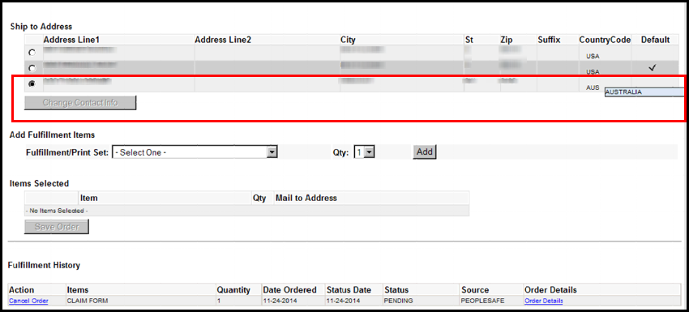

Note: When a foreign address is selected, the Change Contact Info button will be disabled. This information cannot be edited or changed.

Existing letters available for PeopleSafe:
- Abridged formulary packet
- Annual Notice of Change (ANOC)
- Coordination of Benefits Survey Letter
- Comprehensive formulary
- Disenrollment Form
- Evidence of Coverage (EOC) replacement
- LIS Rider
- IRMAA letter ID S026
- Pharmacy List Directory
- Plan star ratings
- Replacement ID card (includes an ID card)
- Summary of Benefits
- Welcome Kit

Step | Action
1 | Determine which documents the beneficiary is requesting.
1 | If… | And Requesting… | Then…
1 | SilverScript Individual  SilverScript EGWP  Blue MedicareRx Individual  Blue MedicareRx EGWP | All the following documents for plan year 2023:  - Evidence of Coverage (EOC)  - Formulary (Comprehensive)  - Pharmacy Directory | Refer to MED D - Digital Evidence of Coverage, Formulary and Pharmacy Directory.
1 | SilverScript EGWP and Blue MedicareRx (NEJE) EGWP | Any document for plan year 2023 | Proceed to the next step.
1 | SilverScript and Blue MedicareRx (NEJE) | Individual or other document(s) | Proceed to the next step.
2 | Under the Medicare D Inquiry Tab, click on the Fulfillment Requests tab.  Reminder: The Medicare D Inquiry tab is only used for SilverScript or Blue MedicareRx (NEJE) clients and those clients who have contracted for SilverScript LLC or Blue MedicareRx (NEJE) to handle their fulfillment requests.  - Before attempting to resolve any fulfillment request, the CCR will review the CIF to determine if CVS Caremark handles the fulfillment for the client.  Return to High Level Process
3 | - Highlight the item being requested in the Fulfillment List section of the screen.  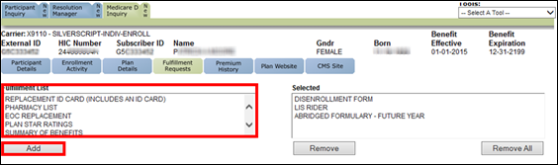  Note: Hold down the Control key to select more than one item.  - Click the Add button.  If the Fulfillment List is not populated, submit the following RM Task:  Task Category: Med D Enrollment - Fulfillment  Task Type: Fulfillment Request  Queue: Med D Enrollment Task  Notes: Include detailed notes in the RM Task:  - Indicate that Med D Fulfillment Tab is not populated.  - Who is placing the request (i.e. beneficiary, POA, AOR or legal representative)  - Item being requested:  - Annual Notice of Change (ANOC)  - Evidence of Coverage (EOC)  - Abridged Formulary  - Low Income Subsidy (LIS) Rider  - Pharmacy Network Listing Directory  - Welcome Packet  Blue MedicareRx (NEJE) Individual Note: If requesting a replacement EOC, Pharmacy List or Comprehensive formulary for 2023, select the following from the Fulfillment list:  - EOC Replacement (DSENO)  - Pharmacy List (DPHAL)  - Comprehensive Formulary – Current Year (DFORM)  Return to High Level Process
4 | Verify the beneficiary’s address and update as needed.  - If the beneficiary requests the item(s) be shipped to a location other than what is listed, select the Change Address button.  - Refer to MED D - Address Changes and Out of Area (OOA).  Return to High Level Process
5 | Click the Save Order button.  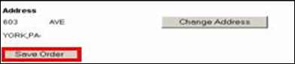  Result: PeopleSafe will add the selected item to the Selected section located on the right.  Note: Items can be removed by highlighting the Selected item(s) and clicking the Remove button.  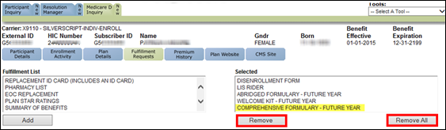  Tips:  - Hold down the Control key to select more than one item.  - The Remove All button can be used when removing all fulfillment items, which are currently in the Selected section.  Return to High Level Process
6 | Explain next steps.  You should receive the requested fulfillment item within 15 business days.  Return to High Level Process

Top of the Document
Fulfillment – Alternate or Accessible Formats
Beneficiaries may request any of the following fulfillment types in an alternate/accessible format listed.

Note: Before attempting to resolve any fulfillment request, the CCR will review the CIF to determine if CVS Caremark handles the fulfillment for the client.

Plan | Fulfillment Type | Alternate Formats
SSI PDP, Blue MedicareRx (NEJE), EGWPs and Health Plans | Any Plan Materials  Exception: Premium Billing Invoices, refer to:  - Aetna MED D - EGWP & SilverScript - Premium Billing Invoice Requests  - MED D - Blue MedicareRx (NEJE) - Premium Billing Invoice Requests | - Large print  - Braille  - Audio CD  Note: The Counsel Sheet (Large Font) option in PeopleSafe will only fulfill the counseling sheet in large print. All other large print requests follow the process below.

Perform the following steps:
Step | Action
1 | - In what accessible format do you need this letter? (Large print, Braille, or Audio CD)  - I would be happy to submit your request. Is this a one-time request or a standing request?  - Health Plans Only, for Standing Requests: Please contact your plan to make them aware of your standing request.
1 | If… | Then…
1 | One-Time Request | Submit the following RM Task:  Task Category: Customer Care Internal Process  Task Type: Account Executive Consideration  Queue: CC Internal Processes – Client Support  Notes: Document the following:  - Beneficiary’s Name  - Beneficiary’s Mailing Address  - Participant External ID (Member ID)  - Letter type  - Original Letter Date  - Alternate/Accessible Format  - One-time Request  - Confirmed the beneficiary received the original letter  Proceed to Step 2.
1 | Standing Request | Health Plans Only, for Standing Requests: Please contact your plan to make them aware of your standing request.  Submit the following RM Task:  Task Category: Customer Care Internal Process  Task Type: Account Executive Consideration  Queue: CC Internal Processes – Client Support  Notes: Document the following:  - Beneficiary’s Name  - Beneficiary’s Mailing Address  - Participant External ID (Member ID)  - Letter type  - Alternate/Accessible Format  - Standing Request  Proceed to Step 2.
2 | Explain next steps.  Health Plans only, for Standing Requests: Please contact your plan to make them aware of your standing request.  You should receive the requested format of your letter within 20 business days.

Top of the Document
Fulfillment – Non-English Language
Beneficiaries may request any of the following letter types in a non-English language.

Note: Before attempting to resolve any fulfillment request, the CCR will review the CIF to determine if CVS Caremark handles the fulfillment for the client.

Plan | Letter
SSI PDP, EGWPs and Health Plans  Note: NEJE does not offer materials in languages other than English. | Any Plan Materials  - Exception: For Premium Billing Invoices, refer to Aetna MED D - EGWP & SilverScript - Premium Billing Invoice Requests.

Perform the following steps:
Step | Action
1 | - In what language do you need this letter?  - I would be happy to submit your request. Is this a one-time request or a standing request?  - Health Plans Only, for Standing Requests: Please contact your plan to make them aware of your standing request.  For Non-English language requests:  - Interpretation should be offered during the call. Refer to MED D - Language Assistance - Language Line Services.  - Printed materials should not be offered to the beneficiary, however, if the beneficiary asks for printed materials, proceed to the following.
1 | If… | Then…
1 | One-Time Request | Submit the following RM Task:  Task Category: Customer Care Internal Process  Task Type: Account Executive Consideration  Queue: CC Internal Processes – Client Support  Notes: Document the following:  - Beneficiary’s Name  - Beneficiary’s Mailing Address  - Participant External ID (Member ID)  - Letter type  - Original Letter Date  - Non-English language  - One-Time Request  - Confirmed the beneficiary received the original letter  Proceed to Step 2.
 | Standing Request | Health Plans Only, for Standing Requests: Please contact your plan to make them aware of your standing request.  Submit the following RM Task:  Task Category: Customer Care Internal Process  Task Type: Account Executive Consideration  Queue: CC Internal Processes – Client Support  Notes: Document the following:  - Beneficiary’s Name  - Beneficiary’s Mailing Address  - Participant External ID (Member ID)  - Letter type  - Original Letter Date  - Non-English language  - Standing Request  Proceed to Step 2.
2 | Explain next steps.  Health Plans only, for Standing Requests: Please contact your plan to make them aware of your standing request.  You should receive the requested version of your letter within 20 business days.

Top of the Document

Viewing Medicare D Fulfillment
The CCR will be able to view the last 12 months’ worth of communications sent to the beneficiary in OneClick.

In order to view the communications mailers, the CCR will refer to MED D - Viewing Correspondence and Requesting Reprints in PeopleSafe.

Top of the Document

Medicare D Monthly Explanation of Benefit (EOB)
Perform the following steps:

Note: ALL MED D items are sent to the MAILING address.
- The beneficiary cannot have for example the Premium Bill sent to one address and the EOB sent to another address.

Step | Action
1 | Review the CIF in order to verify CVS Caremark processes the Explanation of Benefits (EOB) for this client.
1 | If… | Then…
1 | SilverScript LLC processes the EOB | Proceed to Step 2.
1 | Client processes the EOB | Refer or transfer the beneficiary (depending on what the CIF indicates) to the appropriate phone number in the CIF.
2 | Review the View Activity screen to ensure the EOB has not already been requested.
3 | Access OneClick in PeopleSafe. Refer to MED D - Viewing Correspondence and Requesting Reprints in PeopleSafe.
4 | Locate and verify the EOB the beneficiary would like reprinted in the document list.  Note: Review the EOB to confirm it contains the claim dates the beneficiary is requesting.  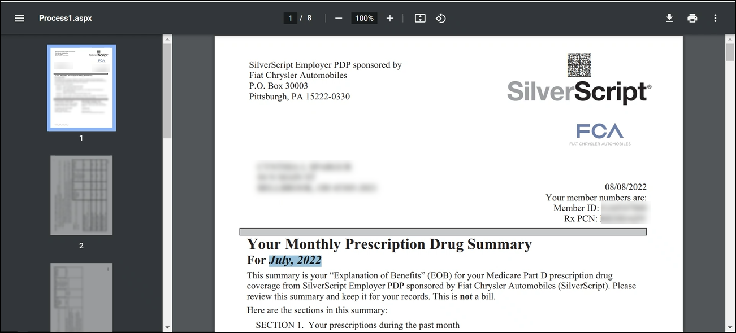
5 | To request a reprint of an existing EOB(s), select the radio button in the Event Code column.  Note: Only one EOB reprint can be selected at a time. If a beneficiary needs multiple EOBs, repeat this process for each EOB.  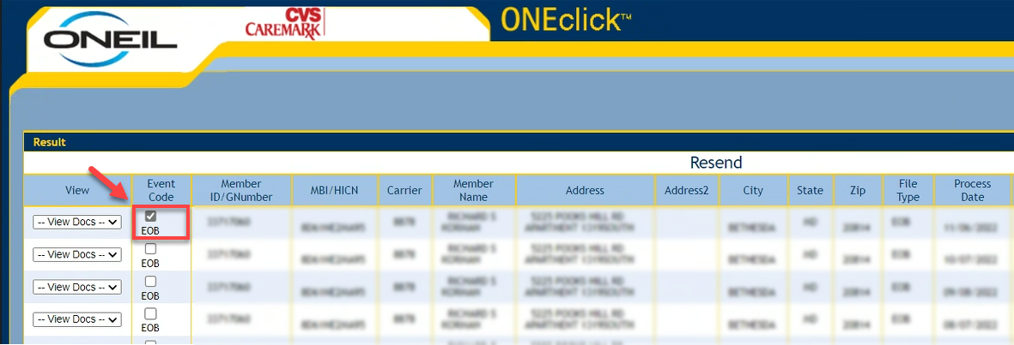
6 | Select Resend.  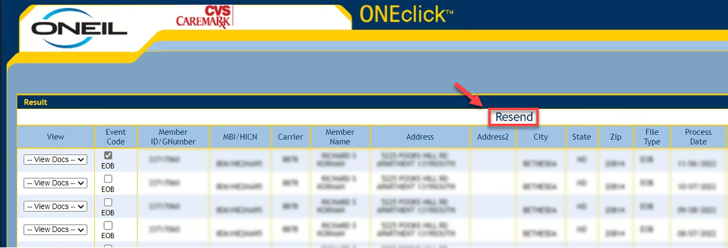
7 | The Confirm Resend Details screen will pop up.  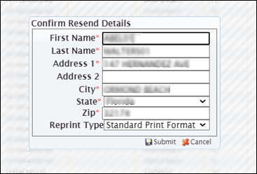
8 | We will request a duplicate copy of the document.  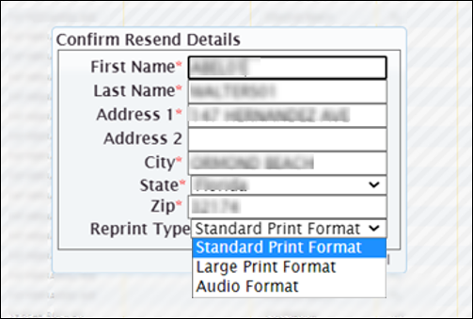  Select Standard Print Format.
9 | Confirm the address the beneficiary would like the EOB reprint mailed to.
9 | If… | Then…
9 | Current address on file | Select Submit to process the reprint.
9 | New address | Is this a temporary address for this EOB reprint only?
9 | New address | If... | Then...
9 | New address | Yes | Update address in Confirm Resend Details screen and click Submit. Document that a one-time address was used for the EOB reprint.  Refer to MED D - Call Documentation Including Viewing and Adding Comments in PeopleSafe.
9 | New address | No | Update address in Confirm Resend Details screen and click Submit and update the address, as appropriate, in PeopleSafe.  Refer to MED D - Address Changes and Out of Area (OOA).
10 | Explain next steps.  You should receive the requested version of your EOB within 20 business days.

Top of the Document

Digital Evidence of Coverage, Formulary and Pharmacy Directory

Refer to MED D - Digital Evidence of Coverage, Formulary and Pharmacy Directory.

Top of the Document

Resolution Manager Task

Perform the following steps:
Step | Action
1 | Verify on the View Activity screen that the Fulfillment Item has not already been requested.
2 | From the Main Screen click the New Resolution Manager tab.  Note: Member detail should transfer.
3 | Select the Fulfillment Task Category from the drop-down menu.
4 | Select the appropriate Fulfillment Type from the drop-down menu.
5 | Populate ALL Required Fields (*).  Note: Ask the beneficiary to provide the shipping address for the request.  - If the beneficiary refuses to provide you with the information, (Example: You tell me what you have on file), then ask the beneficiary if we can use the default address on file. Do NOT read the address to the beneficiary.
6 | Provide detailed information in the Notes field.
7 | Select Save and Close.

Top of the Document

Fulfillment Automation

Perform the following steps:
Step | Action
1 | Review CIF to determine who handles fulfillment.
1 | If... | Then...
1 | Client | Follow direction provided in CIF.
1 | Caremark | Review the CIF to identify if fulfillment items are ordered a specific way.  Examples: Fulfillment completed via the MED D Inquiry Tab, RM TASK, etc.
1 | Caremark | If... | Then...
1 | Caremark | Yes | Follow direction provided in CIF.
1 | Caremark | No | Proceed to next step.
2 | - Click on Order Fulfillment Button on the Main screen.  - Verify Fulfillment History section that the Fulfillment Item has not already been requested.
3 | Verify the address.  Note: If a beneficiary requests the item(s) to be sent to a location other than what is listed, Select Maintain Address.  Refer to:  - MED D - Email and Phone Number Changes and/or MED D - Address Changes and Out of Area (OOA)
3 | If you are speaking with… | Then...
3 | Beneficiary | Proactively verify address for the request and select the radio button for the applicable Ship to Address.
3 | Anyone else | Ask the caller to provide the address.
4 | Select the appropriate fulfillment items from the Fulfillment/Print Set drop-down menu.
5 | Select Quantity (Qty) of selected item from drop down menu.  Note: The maximum quantity that can be ordered at one time is five. If more than five (5) are needed, create a RM Task (Bulk Literature Request). Educate beneficiary that they will receive new pre-populated order forms with every order and many forms are available on the Member Web Portal for printing by the member.
6 | Select Add.  Result: Items display in the Items Selected field. The user can remove an item by selecting the Remove Item link.
7 | Select Save Order to send fulfillment request.  Result: Items display in the Fulfillment History section of the window.  Note: Pre-paid envelopes are not included with any items sent through automation.  The Fulfillment History screen displays:  - Date the item was ordered or canceled  - Status Date  - Status of request (i.e. shipped or canceled)  - Which Source is fulfilling the request (PeopleSafe or IVR)  - Other ancillary information regarding the request (Order Details)  Cancel Order:  - If there is a need to cancel the request, click on the Cancel Order hyperlink.  - The Order Details link provides the specifics of the fulfillment order.  - If no fulfillment items are set up for the client, the below error pop-up displays. Complete a Client Issue Form. Refer to Submitting Feedback and Reporting Client Issues.  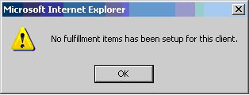
7 | Explain next steps.  You should receive the requested fulfillment item within 15 business days.

Top of the Document

Related Documents
- Grievance Standard Verbiage (for use in Discussion with Beneficiary) section in MED D - Grievances Index
- Log Activity/Capture Activity Codes

Parent SOP: CALL-0048: Medicare Part D Customer Care Call Center Requirements-CVS Caremark Part D Services, L.L.C.
Abbreviations/Definitions: Abbreviations / Definitions

Top of the Document
Not to Be Reproduced or Disclosed to Others without Prior Written Approval
ELECTRONIC DATA = OFFICIAL VERSION – PAPER COPY = INFORMATIONAL ONLY

